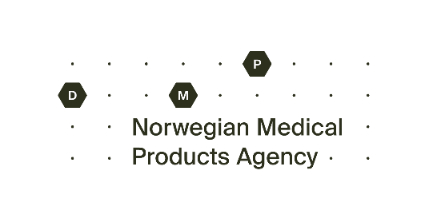
Request for Access to Health Information in the Adverse Reaction Register

Use this form when requesting access to your own registered information linked to your name or national identity number in the Adverse Reaction Register at the Norwegian Directorate of Medical Products (NOMA). The form must also be used when requesting access to information about your own child under the age of 16, a person for whom you are a legal guardian/authorised representative, or a deceased person to whom you are the next of kin.

It is very important that all fields in the form are completed correctly. Please attach a certified copy of personal identification (for example a passport or driving licence). DMP cannot grant access based on incomplete requests or requests containing incorrect information.

1. Information about the person requesting access
Name: | National identity number (11 digits):
Address:
Postcode and town/city: |  | Telephone:

2. The person to whom the health information relates
The request concerns access to health information about (tick the appropriate option below):

me – I am over 16 years of age – go to section 8
a person for whom I am a legal guardian/authorised representative – go to section 3
my child who is under 16 years of age – go to section 4
me – I am under 16 years of age – approval from guardian required – go to section 5
a deceased person to whom I am the next of kin – go to section 6

3. Information about the person under guardianship or represented by an authorised representative (if applicable)
Name: | National identity number (11 digits):
Address:
Postcode and town/city: |  | Telephone:
I have attached documentation confirming that I am the legal guardian or authorised representative.

4. Information about the child under 16 years of age to whom the health information relates (if applicable)
Name: | National identity number (11 digits):

5. Information about the child under 16 years of age to whom the health information relates (if applicable)
Name of guardian 1: | National identity number (11 digits):
Address:
Postcode and town/city: |  | Telephone:
Name of guardian 2: | National identity number (11 digits):
Address:
Postcode and town/city: |  | Telephone:
If the person requesting access is between 12 and 16 years old and does not want the information to be shared with their guardians, please provide a justification (The justification must not include health information or other sensitive personal data):

6. Information about the deceased person to whom I am the next of kin (if applicable)
Name: | National identity number (11 digits):
Address:
Postcode and town/city: |  | Telephone:
Briefly describe your status as the deceased person’s next of kin:

7. Other information
Provide any other information relevant to the request for access:

8. Signature of the person requesting access
Place: | Date:
Signature:

Requests for access must be sent by post to: Norwegian Directorate of Medical Products, PO Box 240 Skøyen, 0213 Oslo.

Responses to requests for access will be sent by registered mail to the address registered in the National Population Register for the person who submitted the request.

