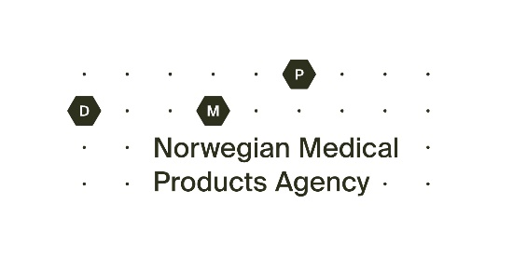
Application for exemption from withdrawal in accordance with Legemiddelforskriften § 8-4 (Sunset Clause)

Send form and any supplementary information to pi@dmp.no

1. Medicinal product
Product name: | MA-number:
Strength:
Pharmaceutical form:

2. Marketing Authorisation holder or representative
Name and address:
Contact:
E-mail:
Phone: | Mobile:

The Marketing Authorization holder for the above mentioned medicinal product(s) requests an exemption from withdrawal on the following public health grounds or exceptional circumstances, in accordance with Legemiddelforskriften § 8-4:

3. Justification for exemption

4. Other relevant information/documentation
Attachment: | Description:

5. Signature
Place: | Date: | Signature:

