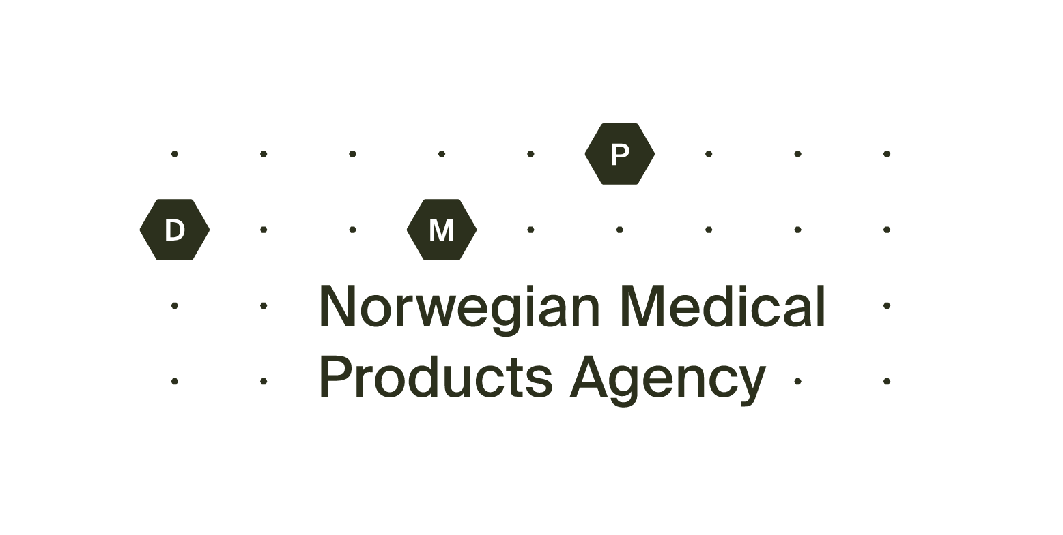Application for variation – parallel imported medicinal product

The completed variation application form must be sent to: post@dmp.no

Information about the medicinal product
Name of the product:
Pharmaceutical form and strength:
Marketing Authorisation Number (MT(PI)no.):
Exporting state:
Name of product in the exporting state:

Information about the variation
Types of change(s):
(tick one or more options and describe the change in a separate attachment)
Name of the Marketing Authorisation Holder in the exporting state
Marketing Authorisation Number in the exporting state
Manufacturer
Updated package leaflet
Relabeling / repackaging
New package size(s)
Storage conditions / Shelf life
Appearance of the medicinal product
Composition
Name, and/or change in the address of the Marketing Authorisation Holder for parallel imported medicinal product
Transfer
Other:
If the variation involves a change in the product information, new drafts must be enclosed, tick off the following boxes:
New draft on package leaflet
New draft on labelling

Information about the Marketing Authorisation Holder for parallel import
Company Name:
Address:
Phone:
E-mail:
Contact person:
Date: | Signature by applicant:

