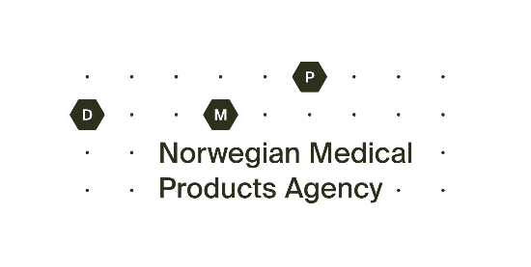
Application for exemption from the conformity assessment procedure (CE-marking) of a medical device
Submit your application to the Norwegian Medical Products Agency: meddev-no@noma.no
Part I – filled in by the manufacturer
Name and address of manufacturer | Contact person for the application, name and address
Device name | The role of the contact person (manufacturer/authorized representative/distributor/importer)
Generic name of the medical device | Telephone number of the contact person
The GMDN-code of the device, if applicable | E-mail address of the contact person
The intended use of the device

Indicate which requirements in the regulation of medical devices the application applies to

Is the device authorized for marketing/use outside the EEA? Attach relevant documentation, e.g. FDA approval

Is the device available on the market in other EEA/EU-states? Enter any number of device units.

Specify the number of devices the application applies to

Specify the time period for which the application applies to

Specify when the device is expected to be CE marked. Attach relevant correspondence with the notified body and timeline for CE-marking

How will the device(s) be handled after the end of the derogation period?

Has the device been used before in clinical trials or performance studies (IVD)?

Describe how the device differs from other similar devices already on the market

Explain the documentation that provides support for the device to be used safely and correct for both the patient and other users. The documentation should also contain information that supports a risk/benefit analysis.

Details on Vigilance or recall issues to date

List any attachments to the application. This can be, for example, a risk analysis, risk management reporting, instructions for use, etc. If the device has an EC-certificate (for relevant risk class) and a Declaration of Conformity, this must always be attached.

Date, name and title |  | Signature

Part II – filled in by the user/clinician
Name and address of user/clinician | Contact person for the application, name and address
Name and address of manufacturer | Telephone number of the contact person
Device name | E-mail address of the contact person
How many patients does the application apply to

Justification based on a specific need of one particular patient or targeted patient group

Indicate what measures have been taken to find an alternative device that meets the requirements of the regulations

Explain why any available CE-marked device(s) or are not a suitable alternative for the patient(s). Describe possible consequences if the patient(s) cannot access the device(s)

Date, name and title (business manager or similar) |  | Signature

First time published: 26.05.2021
Updated: 23.01.2024

